# CHAPTER 6

# IMPLEMENTATION

Implementation is the stage in the project where the theoretical design is turned into a working system and giving confidence on the new system for the users that it will work efficiently and effectively. It involves careful planning, investigation of the current system and its constraints on implementation, design of methods to achieve the changeover, an evaluation of change over methods. Apart from planning major task of preparing the implementation are education and training of users. The implementation process begins with preparing a plan for the implementation of the system. According to this plan, the activities are to be carried out, discussions made regarding the equipment and resources and the additional equipment has to be acquired to implement the new system. In network backup system no additional resources are needed.

**Implementation using PHP:**

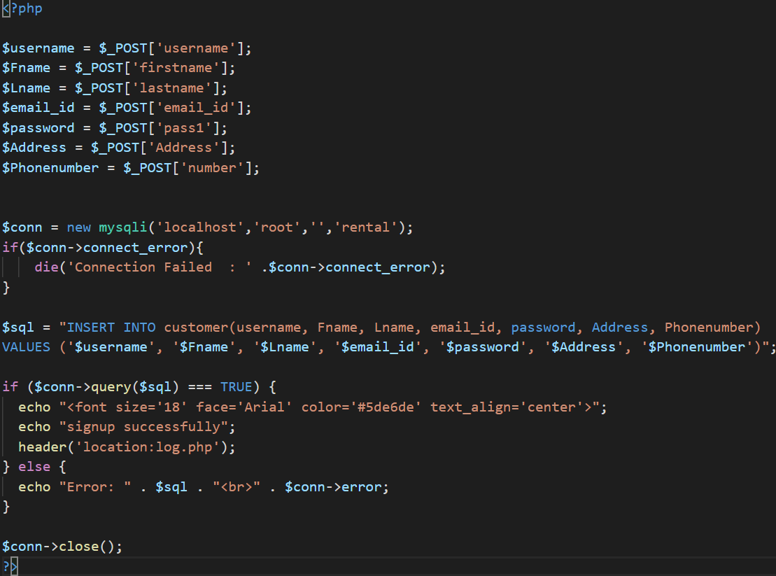

**Figure 6.1: Connection of Signup page with backend**

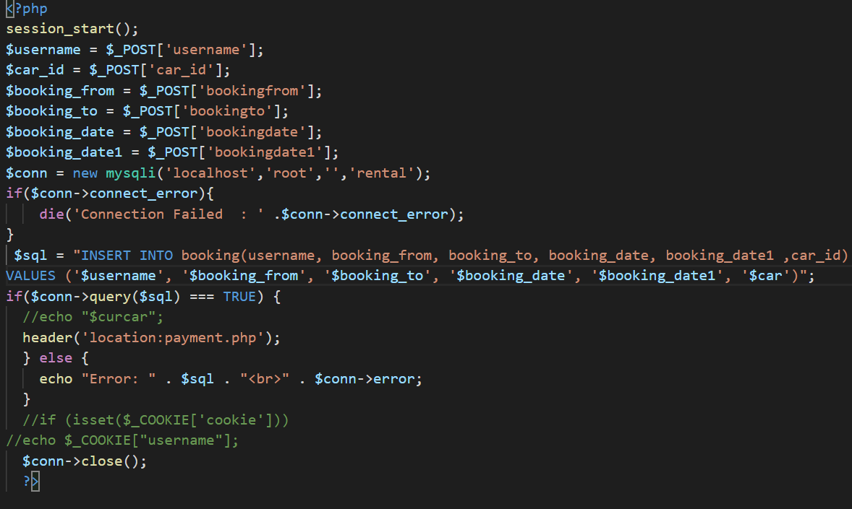

**Figure 6.2: Connection of booking page with backend**

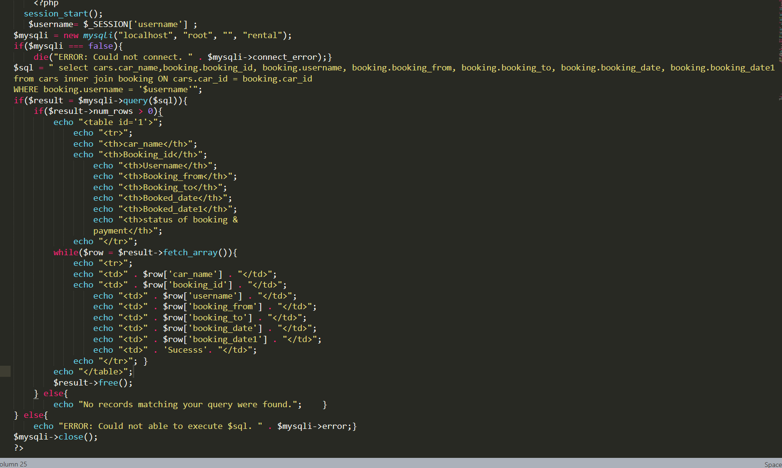

**Figure 6.3: Retrieving data from backend using various PHP functions**